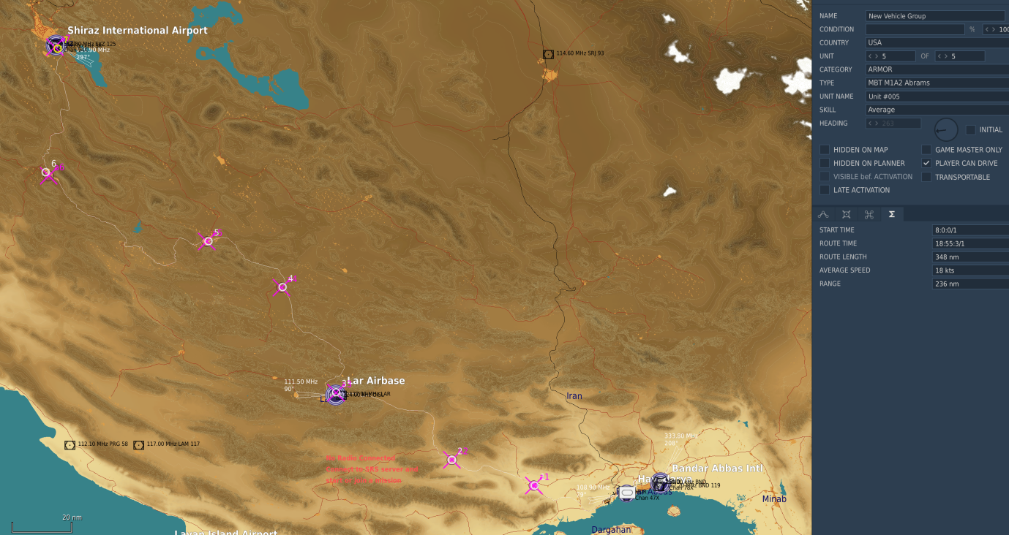

# Design

2-3 hour gaming sessions where AI perform one “hop” and humans would perform usually one flight or Tasking. Time per session/hop could be tailored up/down as suits, but the point is to have distinct sessions and stages that can be measured and repeated and reused.

The proposed design is 3 weeks. With the above “rough” sketch of 350nm it appears 7 sessions are required, which means either two sessions per week or 6 weeks would be more appropriate as a minimum and build on top of that failure. Or a shorter end goal.

DCS units will get to each zone on time only if not entering combat on the way. Some time padding is required to build into that.

Each session has a start criteria to get the ground forces spawning in and moving. At the destination they stop and despawn into the town. This is to prevent “offline decimation” by uncontrolled AI. This accomplishes two objectives.

1. Persistence and server running continuously
2. Closely organised troop movement that operate at a specific time in real world

Normally these two parts would not work together since the server AI has 168 per week compared to humans only having a 2-3 hour Sunday flight and possible Wednesday 2-3hr. A ratio of 28:1 extra time for AI. It is not a proposal for troops to move without large 132nd presence.

Each “organised game session” would therefore kickoff movement and objective taking, but the sandbox environment and static targets would remain perpetual at all other times, allowing for some flights to occur at other times.

It is proposed to have 3 paths of advancement, in something like company level for unit handling. This will provide a broad and varied scenario and it is unlikely that players will revisit any of the same AO. Each path will visit it’s own route and have it’s own objectives which will be distributed to players.

# Session ground movement in detail

## Start of movement

In order to guarantee at least a known good place, Each company will remain despawned, as if dug in. The start of a gaming session can be done in various ways as a trigger. Options include

1. Most basic, a Menu item presented to a specific player or a specific slot. 3 entries – advance company A, B, C. Advantages: tight control, ability to cancel an advance due to lack of attendance. Least scripting required
2. By Proximity/inhabitancy of a plane/slot, area. Less control, but no manual effort. More scripting required to create those triggers, may require sperating slots into different alignments of advancements.
3. By sheer number of players. Least control. Could activate movements based on how many people were logged into the server.

Either way the trigger is done, once activated, the Company spawns in from a disguised location (like forest, town) and then has one waypoint to the next zone.

## On the way

At the same time as triggering to start the advance, we allow other things to happen.

1. Begin launching enemy CAS strikes like helicopters from Zone end to Zone origin. This provides a CAP/BARCAP tasking
2. Spawn in some random placed Red “en route” blockers, things to create a battle with. Ambushes and the like. These would be late activated and manually placed so as to give a little more for the escorting parties to deal with. This provides an Escort/CAS tasking.
3. Spawn in the main force at the destination. This would also be late activated and represent dug in forces that are defended by AD. This provides a SCAR/BAI tasking.

## End of Movement phase

Four outcomes exist at session end

1. The advancing company arrives in the destination zone and it has been cleared
2. The advancing company arrives in the destination zone and it is contested by reds present
3. The advancing company is still en route
4. The advancing company was completely destroyed

### The advancing company arrives in the destination zone and it has been cleared

* A status will be written to disk for sending to the back end server
* The advancing company will despawn nicely out of site.
* Blue defences will spawn in, some small Air Defences. This will keep the zone as “blue” and recorded as such.

### The advancing company arrives in the destination zone and it is contested by Reds present

If there are both red and blue forces in the objective zone, the Blue company should not despawn. This should be a signal that Blue air have not sanitized the area.

This will be handled by no advancement stage on the next period, just a CAS ATO at that location. Blue Company will remain stationary and do nothing except defend itself, it has no orders. As soon as that situation resolves, they will despawn and Blue reinforcements will appear.

## Incompletion or failure

If incomplete at “RL session end” this is feedback the hop was too long.

AI will have it’s way and a report of Blue’s status to the back end server will be made regardless. If at server save time and the Company is “stuck” or still short of the destination, a new company will be created once the trigger is begun at server start. I’m not sure what to do with the existing failed Company. Either delete or leave. CA slots could get it to move.

## Stranded Red units

Stranded red units are likely. They will be saved in situ. The Mission Designer (MD) should make every care not to place them in unobvious locations that could create an immediate firefight on spawn of the blue in the next hop stage.

# Server actions and status

Things we know:

* Which zones are blue and which zones are red and which are contested with both.
* The order of zones, they are linear
* The coordinates of zones
* The start of the session trigger
* The end of the session
* The fact that the Company is in progress advancing

Each of these is all we need to provide the logic. The zone “ownership” will be written to disk as and when it happens, providing the “progress”.

An ATO brief output can be created every 15 minutes on a schedule via a function that checks all the above and creates a table for uploading. It’s almost a Finite State Machine.

## Examples

All ATO’s are created at server start. They may change during the session.

**Zones = {[A1]=”blue”, [A2]=”contested”, [A3]=”red”}**

**Company A reached Zone A2**

We know A2 is in contention and needs resolved.

The above table will generate an ATO of:

* Primary: CAS in support of Company A at zone A1, co-ords of A1 are: 123456
* Secondary: SCAR at Zone A3
* CAP between A2 and A3

**Zones = {{[A1]=”blue”, [A2]=”red”, [A3]=”red”} will create the following:**

* Company A spawning at A1 and going to A2
* ATO task SCAR at A2
* ATO task CAS/Escort from A1 to A2
* CAP between A1 and A2

# Scripting Feature Layers

## Blue controller Schedule

At mission start, a function that runs in a schedule to recognise the zone layout, start the Blue advances, stop and dig in if required, spawn in reds, start and stop the Red Ground attacks, spawn in random SAM layers, update tables to disk, limits units, counts numbers of groups for balancing, update the ATO.

## A2A_Dispatcher

GCI and Red CAP will be present, with a border that encompasses the entire Iranian AO, starting from the first zones. This will hamper all Blue airborne efforts. It may be moved, affected by the controller schedule

## Red Custom Ground Attack

These will use the status of the mission to target the lines of advance. Optionally they may attack mainland Oman/UAE. Depends on desire/unit count.

## Fixed SAM emplacements

Fixed SAM’s are SAM’s that are pre-placed on the map over key installations. They will be assessed as a fixed list by the ATO. Humans are required to do the BDA via the ATO mechanism so that they are not duplicated.

## Mobile SAM and AAA emplacements

Mobiles are spawned in randomly around the routes, usually around towns and outside zones so as not to interfere.

## CTLD

Logistics based Rotary should have some ability to deliver AD or something else. This ATO could be added as manual, like “Reinforce Zone A1”, “place air defences at between Zone A2 and Zone A3”

## CSAR

Could be fun. Could force reprioritisation of Logistics Rotary from their logistic tasks. Could require RESCAP ATO’s.

## ATO function

The ATO will assess the Zones and change the ATO’s present on the webpage

## GM tools

A standalone toolset for deleting, spawning and moving and bumping things in case it’s needed mid mission

## Messaging

Some in game Messages may be required. This could be handled with custom sounds, messages to screen.

## Server Restarter

The server must be restarted every so often to prevent damaged unit accumulations, memory leaks, repair runways, remove craters and server maintenance. A good guideline is 4-7 hours uptime before restarting.